
QUALITY ALERT

Customer: Centra Date: Jan 14, 2025
Die: 15958 Colour: All
Type of Complaint: Centra REJECTED

Q.A # Q.I.R # CUSTOMER NCR #

Description: Centra REJECTED – fin holes are too high from end, make it hard to put nails in.

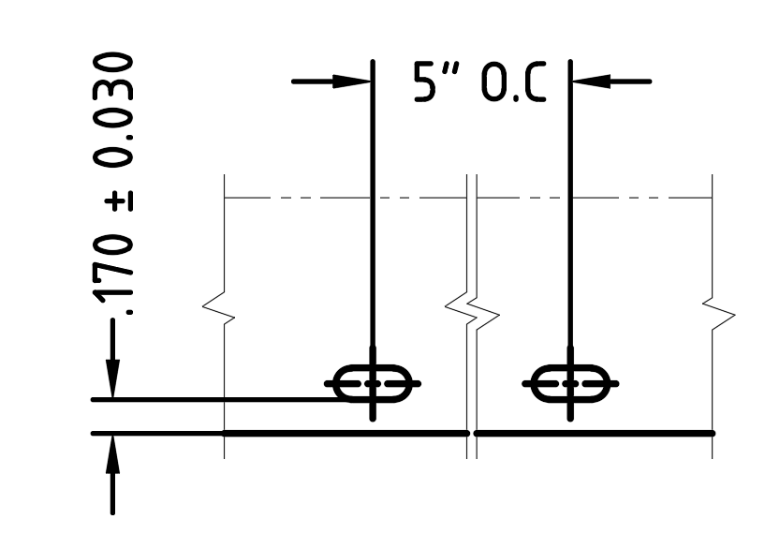
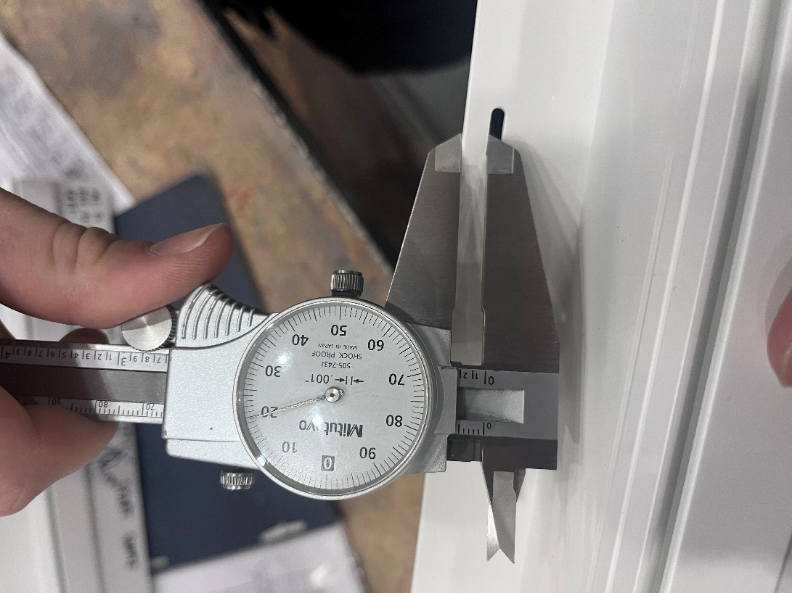

PLEASE MAKE SURE FIN HOLES ARE WITHIN TOLERANCE

BY SIGNING BELOW, YOU ACKNOWLEDGE THE PROBLEM ABOVE AND AGREE TO MONITOR THIS ISSUE IN FUTURE PRODUCTION RUNS.
DAY SHIFT |  | AFTERNOON SHIFT |  | NIGHT SHIFT
NAME | SIGNATURE | NAME | SIGNATURE | NAME | SIGNATURE

